Cleaning data from the FT-IR spectrometer

The data from this equipment contains some noise. This module uses a Savitzky-Golay filter with user definable width, degree and order to clean the data.
The data is expected in a CSV comma delimited file, with the spectral data in columns.
The module allows cleaning of selected spectral data.
The software is developed in ENVI/IDL.

Installation
The software needs to be installed in the ENVI save_add folder. Look here for more details: http://www.itc.nl/personal/nieuwenh/installations.html

Running
On the ENVI command line type: SavgolCleanGUI

User interface
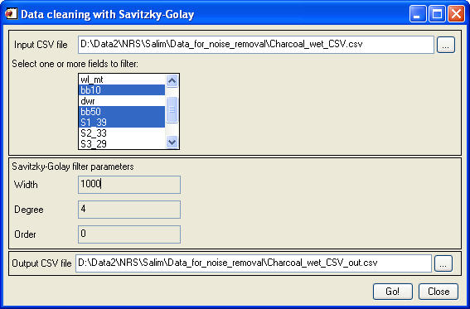

The GUI is self-explaining, with entries for input, spectral data selection, the filter parameters, and output.

When an input CSV is selected, the GUI lists all fields in the list box.

The filter parameters:
- Width: the number of points taken into account when evaluating a data point; the evaluated point is in the middle.
- Degree: the degree of the smoothing polynomial function
- Order: the order 0 will cause the function to smooth the spectral data; values of 1 and higher will give smooth derivative data (1st derivative, 2nd derivative etc)

Running with the parameters as above (width = 1000, degree = 4, order = 0) gives the following result (for bb10 only):
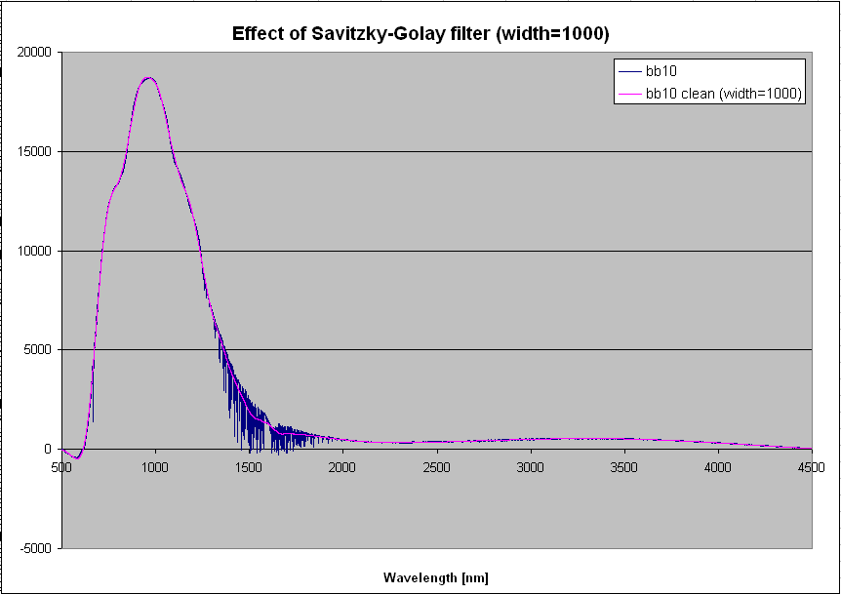

Reference:
Savitzky-Golay filter in IDL (SAVGOL, and CONVOL); SAVGOL is based on the Savitzky-Golay Smoothing Filters described in section 14.8 of Numerical Recipes in C: The Art of Scientific Computing (Second Edition), published by Cambridge University Press

